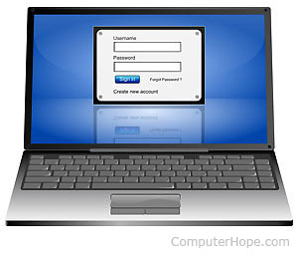







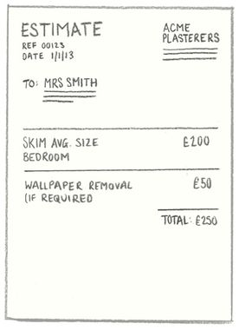




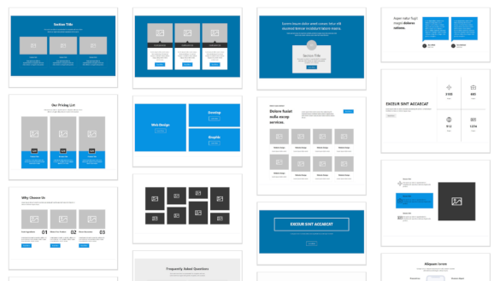







1: Warm up Phase: Discovery of the topic

2: what is it about? alphabet / symbols

3: understand & share emails and password

4: expected outcome: understand & write an email address spelt by someone

A  [eille] | B  [bi] | C  [si] | D  [di] | E  [i]
F  [ef] | G  [dji] | H  [eilletch] | I  [aille] | J  [djeille]
K  [keille] | L  [el] | M  [em] | N  [en] | O  [oh]
P  [pi] | Q  [kiou] | R  [aaar] | S  [es] | T  [ti]
U  [you] | V  [vi] | W  [dablyou] | X  [ex] | Y  [why]
Z
[zed / zi]

Practice the pronunciation of the alphabet and then Play the 4 in a row game!
https://www.anglaisfacile.com/exercices/exercice-anglais-2/exercice-anglais-17819.php?guide=1

Kick-off Phase: Discovery of the topic

A | B | C | D | __ E | F | G
H Standard language for creating Web pages & describes the structure of a Web page. It consists of a series of elements that tell the browser how to display the content | I  It runs a block of code based on whether or not a condition is true. | J  Minecraft was completely developed in this language by Markus Persson as well as Gmail because it has a great performance rate and a good framework for web. | K | L  is used to repeat a block of code until the specified condition is met. | M | N
O | P This language is the most user-friendly programming language. If you’re interested in back-end, for example, then the open-source framework is easy to learn & feature-rich. | Q | R | S | T | U
 | V | W  This statement lets you repeat a statement until a specified expression becomes false. | X includes everything developers need to create apps for Mac, iPhone, iPad, Apple TV, & Apple Watch. It provides them a unified workflow for user interface design, coding, testing, & debugging. | Y | Z

‘FOUR - IN - A - ROW’ SYMBOLS

! | @ | % | & | .
<> | () | : | → | _
/ | $ | ( | * | -
\ | ) | # | ? | {}
; | '……..' | [] | = | £

Analyzing: what is it about? key words
How do you read an email address?

1 | reservationslcy@qbichotels.com | 5 | Satya.nadella@gmail.com
2 | jennifer78@morten-keira.dk | 6 | lee-freezel@rmail.com
3 | mr.jdavis@ecorp.com | 7 | stephanie@oneilsbabyshowers.com
4 | jane.hr@bkauto.com | 8 | johnandjill@gmail.com

expected outcome: understand & write an email address spelt by someone

NOW, Your GO:
Complete the following table with the 10 emails using the link: https://www.youtube.com/watch?v=2BJ-SSjvk38
Set 1
1 johnnie.gable@gmail.com
2 christina_smith@yahoo.com
3 jakeriley_85@yahoo.com.au
4 jenny-tyler@tyler.co.uk
5 lexie.alexander@gmail.com
6
7
8
9
10

Work with a mate & exchange INFORMATION!

Product Name: ____________________________________________

Brand name: ____________________________________________
Model number: ____________________________________________
Year of release: ____________________________________________

Processor model Number: ____________________________________________

Processor speed: ____________________________________________

Storage type: ____________________________________________

Total storage capacity: ____________________________________________

Total state drive capacity: ____________________________________________

System memory: ____________________________________________

System memory RAM expandable to: ____________________________________________

Graphics: NVIDIA Getforce ____________________________________________

Video memory: ____________________________________________

Operating system: ____________________________________________

Product Height: ____________________________________________

Product Width: ____________________________________________

Product Weight: ____________________________________________
Free Geek tech support available ____________________________________________
Free delivery and standard installation
Protect your computer with a 1-Year Accidental Geek Squad Protection of _____________, about ___________ / month

